Part one:



1. (a|b)cd\*



1. a(bc)\*d

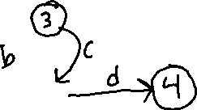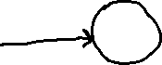

1. (a|b)\*(abb|a+b)

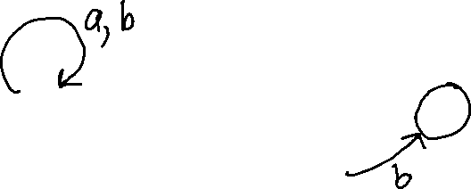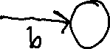

Part two:

